NYU STEINHARDT
MUSIC AND PERFORMING ARTS PROFESSIONS

The Department of Music and Performing Arts Professions, established in 1925, serves as the University’s “School of Music.” It has developed into a major research and practice center in music technology, music composition, music business, film scoring, songwriting, music performance practices, performing arts therapies, and the performing arts-in-education (music, dance, and drama). 1,600 students major in renowned music and performing arts programs, guided by a faculty of over 450. Our degree programs - baccalaureate through PhD - share Steinhardt’s entrepreneurial spirit that encourages innovation and the pursuit of high artistic and academic goals. Our expertise and diverse interests spark the collaborations that bring performers and composers together with technologists, business entrepreneurs, arts managers, filmmakers, choreographers, actors, librettists, and educators – often reviewed by the New York and national media. Faculty sit on leading journal editorial boards and publish some of today’s most significant performing arts and technology research. Our department and Steinhardt offer an unparalleled environment for artistic, professional, entrepreneurial, and scholarly challenge and growth, all in the latest context of emerging technologies. Our department’s designation affirms that all of our curricula are directly linked to the professions that are centered here in the cultural capital of the world.

Our students receive intensive training in individual specializations, and acquire the multiple skill sets and breadth of experience necessary for pursuing successful and fulfilling careers. We encourage students to take courses and interact with faculty across traditional programmatic and school lines. These multiple University synergies, invigorated by the bohemian legacy that defines Greenwich Village, blend into the world’s epicenter of the performing arts: New York City. Drawing upon the greatest artist faculty in the world, our students build networks and engage in rich professional opportunities. We broaden their education with options to study abroad at NYU campuses in Paris and Prague.

Alumni have moved on to major performing and composing careers, and serve in coveted positions within the music and performing arts industry. They hold faculty and administrative positions in colleges, conservatories, and universities throughout the world. Celebrated graduates include jazz great Wayne Shorter, multiple Tony Award-winning music theatre composer Cy Coleman and lyricist Betty Comden, multiple Oscar-winning film composer Elmer Bernstein, conductor/composer Tania Leon, music technologist Enoch Light, and Tony Award-, Oscar-, and Pulitzer Prize-winning playwright and screenwriter John Patrick Shanley.

- Dr. David Schroeder, Director

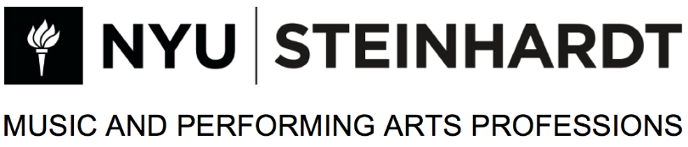

Presents

Name of Recitalist, Instrument

Name of Accompanist, Piano

In partial fulfillment of requirements
For the degree of Bachelor of Music

Day, Date, 2020
Time a.m. or p.m.
Venue
Address 1
New York, NY

Program

Name of piece Composer
(composer dates optional)

This program is No. #1 in a series, 2021-2022, NYU.

